> ##Reading dataset

> cars<-read.csv("Car Mileage Dataset.csv")

>

> ##Normalizing the variable names

> ##install.packages("rattle")

> library(rattle)

> names(cars)

[1] "MPG" "Cylinders" "Displacement" "Horsepower" "Weight" "Acceleration"

[7] "Model_year" "Year_03_06" "Year_07_11" "Year_12_15" "Origin" "Car_Name"

> names(cars)<-normVarNames(names(cars))

>

> ##Understanding the datastructure for data preparation

> str(cars)

'data.frame': 398 obs. of 12 variables:

$ mpg : num 8 15 18 16 17 15 14 14 14 15 ...

$ cylinders : int 8 8 8 8 8 8 8 8 8 8 ...

$ displacement: num 307 350 318 304 302 429 454 440 455 390 ...

$ horsepower : Factor w/ 94 levels "?","100","102",..: 17 35 29 29 24 42 47 46 48 40 ...

$ weight : int 3504 3693 3436 3433 3449 4341 4354 4312 4425 3850 ...

$ acceleration: num 12 11.5 11 12 10.5 10 9 8.5 10 8.5 ...

$ model_year : int 2015 2015 2015 2015 2015 2015 2015 2015 2015 2015 ...

$ year_03_06 : int 0 0 0 0 0 0 0 0 0 0 ...

$ year_07_11 : int 0 0 0 0 0 0 0 0 0 0 ...

$ year_12_15 : int 1 1 1 1 1 1 1 1 1 1 ...

$ origin : int 1 1 1 1 1 1 1 1 1 1 ...

$ car_name : Factor w/ 305 levels "amc ambassador brougham",..: 50 37 232 15 162 142 55 224 242 2 ...

> ##Splitting dataset for further analysis

> cars_num<- subset(cars,select = c(mpg,

+ displacement,

+ horsepower,

+ acceleration,

+ weight))

>

> cars_date<-subset(cars, select=c(year_03_06, year_07_11, year_12_15))

> ##Data visualization

> ##Displacement

> par(mfrow=c(2,2), oma=c(0,0,1,0))

> plot(cars_num$displacement,cars_num$mpg, pch=19,main="Scatter plot", col="orange")

> boxplot(cars_num$displacement, main="Boxplot", col="blue")

> hist(cars_num$displacement, main="Histogram", col="red")

> qqnorm(cars_num$displacement, main="Q-Q Plot", col="green")

> title("Displacement", outer=TRUE)

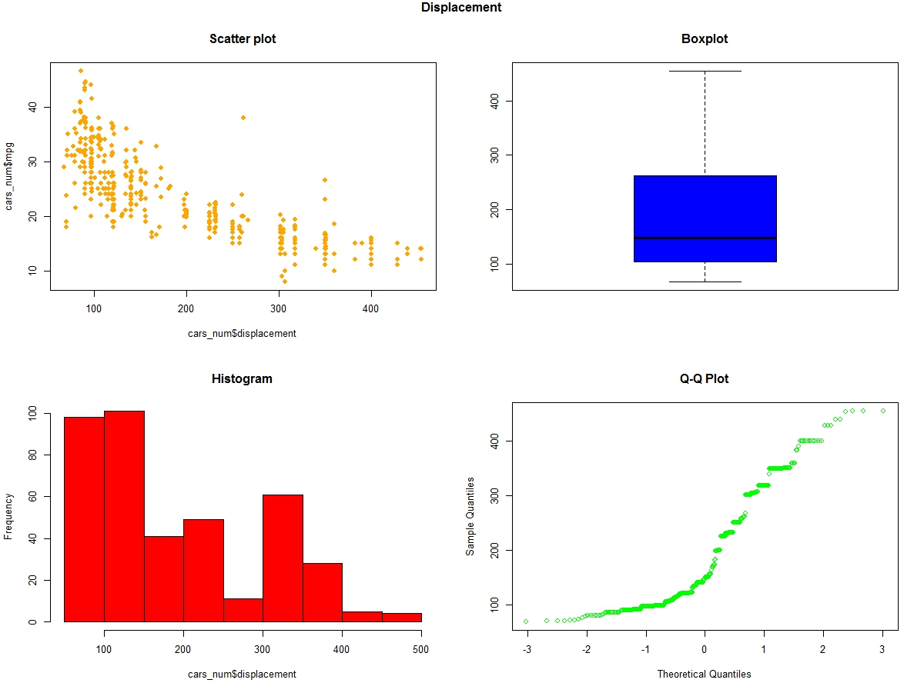

> ##Horsepower

> plot(cars_num$horsepower,cars_num$mpg, pch=19,main="Scatter plot", col="orange")

> boxplot(cars_num$horsepower, main="Boxplot", col="blue")

> hist(cars_num$horsepower, main="Histogram", col="red")

> qqnorm(cars_num$horsepower, main="Q-Q Plot", col="green")

> title("Horsepower", outer=TRUE)

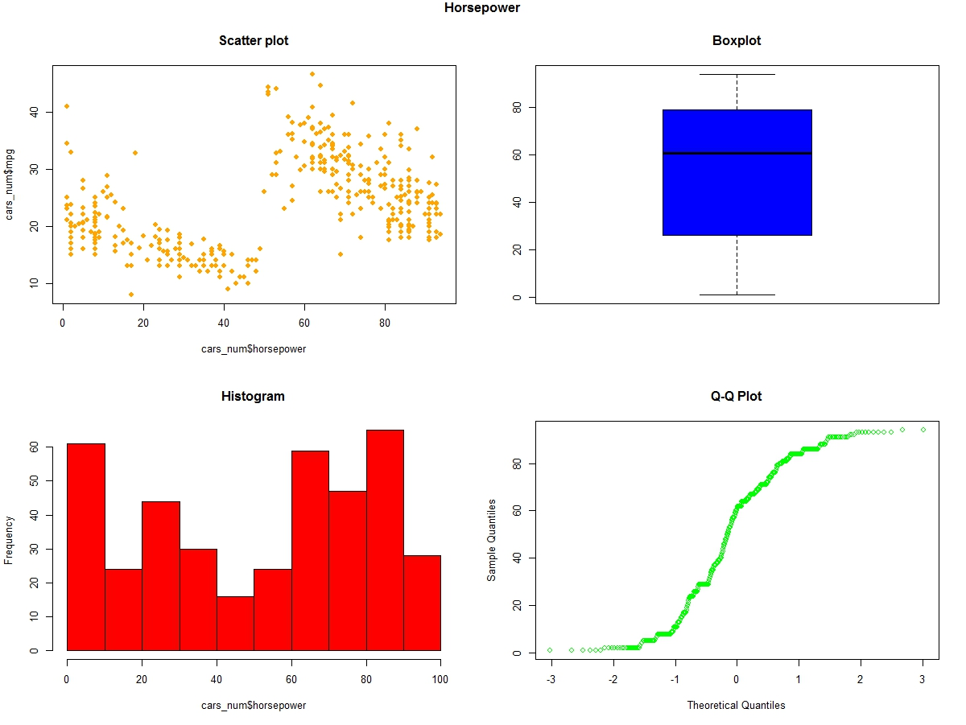

> plot(cars_num$acceleration,cars_num$mpg, pch=19,main="Scatter plot", col="orange")

> boxplot(cars_num$acceleration, main="Boxplot", col="blue")

> hist(cars_num$acceleration, main="Histogram", col="red")

> qqnorm(cars_num$acceleration, main="Q-Q Plot", col="green")

> title("Acceleration", outer=TRUE)

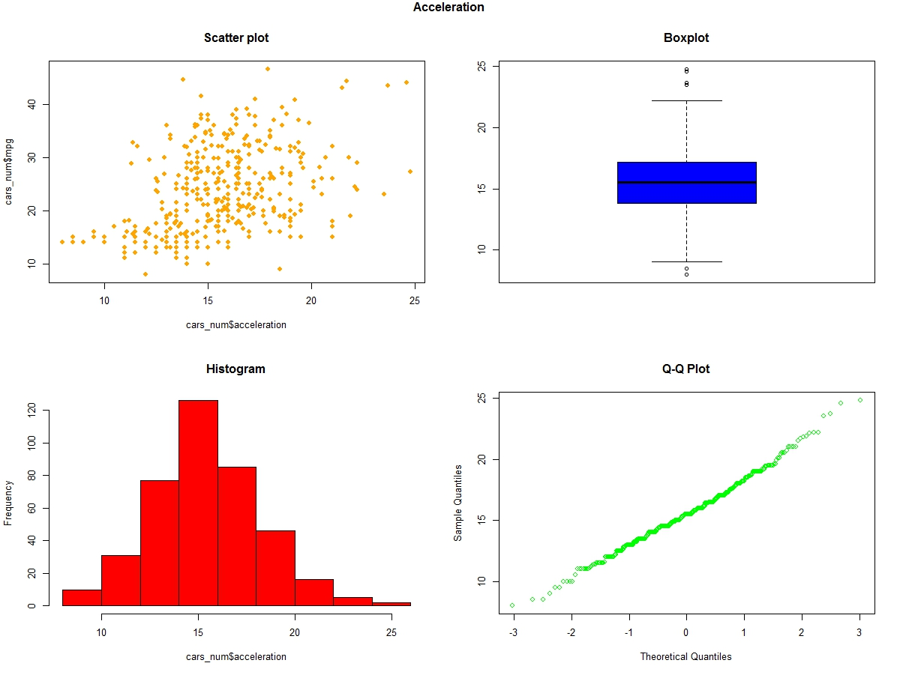

> ##Weight

> plot(cars_num$weight,cars_num$mpg, pch=19,main="Scatter plot", col="orange")

> boxplot(cars_num$weight, main="Boxplot", col="blue")

> hist(cars_num$weight, main="Histogram", col="red")

> qqnorm(cars_num$weight, main="Q-Q Plot", col="green")

> title("Weight", outer=TRUE)

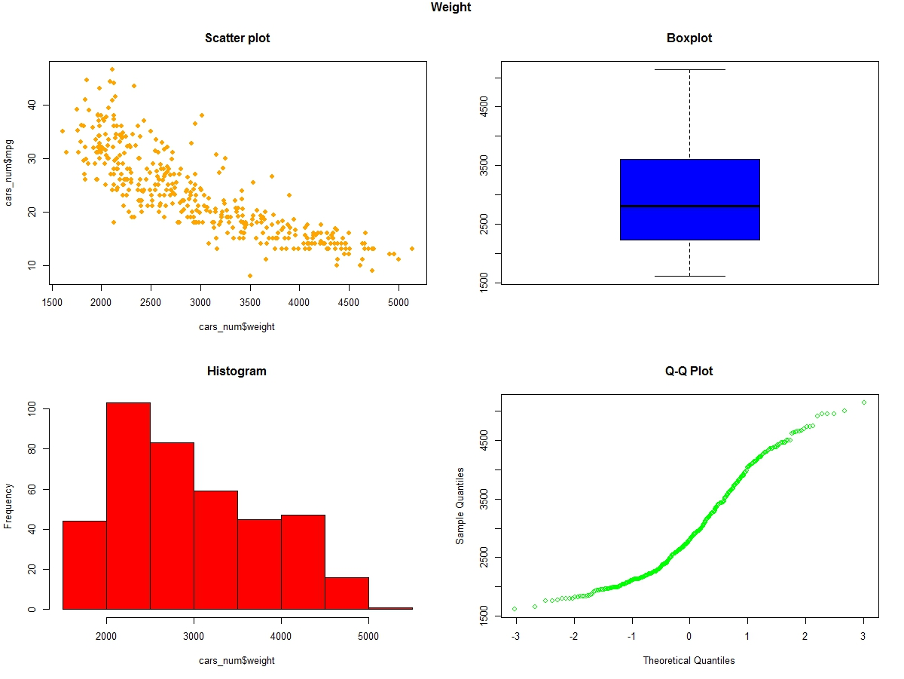

> ##Correlation plot

> ###install.packages("corrplot")

> library(corrplot)

> cor_cars<-cor(cars_num)

> corrplot(cor_cars, method="number")

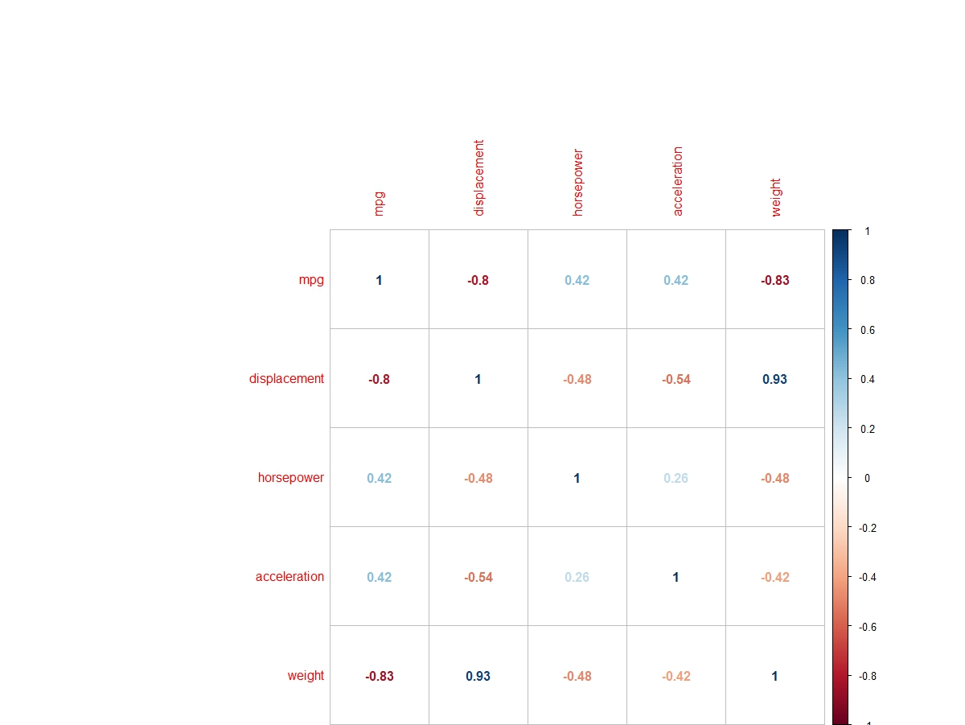

> ##Create dummy variable

> ###install.packages("caret")

> library(caret)

> dummy_cyl<-(predict(dummyVars(mpg~cylinders, data=cars), newdata=cars))

> dummy_cyl<-dummy_cyl[,-1]

>

> dummy_org<-(predict(dummyVars(mpg~origin, data=cars), newdata=cars))

> dummy_org<-dummy_org[,-1]

>

> ##Arranging the required dataset in one dataframe

> data<-cbind(cars_num, dummy_org,dummy_cyl, cars_date )

> head(data)

mpg displacement horsepower acceleration weight origin.2 origin.3 cylinders.4 cylinders.5 cylinders.6

1 8 307 17 12.0 3504 0 0 0 0 0

2 15 350 35 11.5 3693 0 0 0 0 0

3 18 318 29 11.0 3436 0 0 0 0 0

4 16 304 29 12.0 3433 0 0 0 0 0

5 17 302 24 10.5 3449 0 0 0 0 0

6 15 429 42 10.0 4341 0 0 0 0 0

cylinders.8 year_03_06 year_07_11 year_12_15

1 1 0 0 1

2 1 0 0 1

3 1 0 0 1

4 1 0 0 1

5 1 0 0 1

6 1 0 0 1

> ##Fitting regression model

> model<-lm(mpg~.,data=train)

> summary(model)

Call:

lm(formula = mpg ~ ., data = train)

Residuals:

Min 1Q Median 3Q Max

-8.2704 -1.7165 0.1033 1.5487 11.6399

Coefficients: (1 not defined because of singularities)

Estimate Std. Error t value Pr(>|t|)

(Intercept) 26.1123357 2.6816916 9.737 < 2e-16 ***

displacement 0.0142230 0.0085933 1.655 0.099076 .

horsepower -0.0038425 0.0078439 -0.490 0.624627

acceleration 0.2938442 0.0981134 2.995 0.003004 **

weight -0.0064594 0.0006714 -9.620 < 2e-16 ***

origin.2 2.1541302 0.6622924 3.253 0.001292 **

origin.3 2.4503120 0.6507149 3.766 0.000205 ***

cylinders.4 6.4891373 2.0182131 3.215 0.001464 **

cylinders.5 5.8946738 2.8331962 2.081 0.038430 *

cylinders.6 3.6959694 2.2153652 1.668 0.096426 .

cylinders.8 5.4180474 2.6318099 2.059 0.040499 *

year_03_06 7.6164528 0.5574875 13.662 < 2e-16 ***

year_07_11 2.4499365 0.5062980 4.839 2.21e-06 ***

year_12_15 NA NA NA NA

---

Signif. codes: 0 ‘***’ 0.001 ‘**’ 0.01 ‘*’ 0.05 ‘.’ 0.1 ‘ ’ 1

Residual standard error: 3.226 on 266 degrees of freedom

Multiple R-squared: 0.8465, Adjusted R-squared: 0.8396

F-statistic: 122.3 on 12 and 266 DF, p-value: < 2.2e-16

> ##Step wise regression

> ##install.packages("MASS")

> library(MASS)

> step<-stepAIC(model, direction="both")

Start: AIC=666.24

mpg ~ displacement + horsepower + acceleration + weight + origin.2 +

origin.3 + cylinders.4 + cylinders.5 + cylinders.6 + cylinders.8 +

year_03_06 + year_07_11 + year_12_15

Step: AIC=666.24

mpg ~ displacement + horsepower + acceleration + weight + origin.2 +

origin.3 + cylinders.4 + cylinders.5 + cylinders.6 + cylinders.8 +

year_03_06 + year_07_11

Df Sum of Sq RSS AIC

- horsepower 1 2.50 2770.8 664.49

<none> 2768.3 666.24

- displacement 1 28.51 2796.8 667.10

- cylinders.6 1 28.97 2797.2 667.14

- cylinders.8 1 44.11 2812.4 668.65

- cylinders.5 1 45.05 2813.3 668.74

- acceleration 1 93.35 2861.6 673.49

- cylinders.4 1 107.59 2875.8 674.88

- origin.2 1 110.10 2878.4 675.12

- origin.3 1 147.57 2915.8 678.73

- year_07_11 1 243.68 3011.9 687.78

- weight 1 963.19 3731.4 747.54

- year_03_06 1 1942.50 4710.8 812.56

Step: AIC=664.49

mpg ~ displacement + acceleration + weight + origin.2 + origin.3 +

cylinders.4 + cylinders.5 + cylinders.6 + cylinders.8 + year_03_06 +

year_07_11

Df Sum of Sq RSS AIC

<none> 2770.8 664.49

- displacement 1 27.64 2798.4 665.26

- cylinders.6 1 29.06 2799.8 665.40

+ horsepower 1 2.50 2768.3 666.24

- cylinders.5 1 44.12 2814.9 666.90

- cylinders.8 1 45.55 2816.3 667.04

- acceleration 1 92.44 2863.2 671.65

- cylinders.4 1 105.10 2875.9 672.88

- origin.2 1 113.74 2884.5 673.71

- origin.3 1 147.04 2917.8 676.92

- year_07_11 1 249.55 3020.3 686.55

- weight 1 964.73 3735.5 745.84

- year_03_06 1 1968.55 4739.3 812.25

> step

Call:

lm(formula = mpg ~ displacement + acceleration + weight + origin.2 +

origin.3 + cylinders.4 + cylinders.5 + cylinders.6 + cylinders.8 +

year_03_06 + year_07_11, data = train)

Coefficients:

(Intercept) displacement acceleration weight origin.2 origin.3 cylinders.4

26.029223 0.013981 0.292243 -0.006464 2.181622 2.445725 6.348694

cylinders.5 cylinders.6 cylinders.8 year_03_06 year_07_11

5.826458 3.701659 5.496124 7.639648 2.470612

> ##Final model after several trails

>

> model_F<-lm(formula = mpg ~ weight + origin.2 + origin.3 +

+ cylinders.6 + year_03_06 + year_07_11,

+ data = train)

> summary(model_F)

Call:

lm(formula = mpg ~ weight + origin.2 + origin.3 + cylinders.6 +

year_03_06 + year_07_11, data = train)

Residuals:

Min 1Q Median 3Q Max

-9.0330 -1.8844 0.0389 1.7628 12.8498

Coefficients:

Estimate Std. Error t value Pr(>|t|)

(Intercept) 37.3210712 1.1739776 31.790 < 2e-16 ***

weight -0.0057793 0.0003039 -19.020 < 2e-16 ***

origin.2 1.9856199 0.6191600 3.207 0.00150 **

origin.3 1.7604034 0.6392194 2.754 0.00628 **

cylinders.6 -1.8956871 0.5093306 -3.722 0.00024 ***

year_03_06 7.6374228 0.5458576 13.992 < 2e-16 ***

year_07_11 2.4154432 0.4931275 4.898 1.66e-06 ***

---

Signif. codes: 0 ‘***’ 0.001 ‘**’ 0.01 ‘*’ 0.05 ‘.’ 0.1 ‘ ’ 1

Residual standard error: 3.344 on 272 degrees of freedom

Multiple R-squared: 0.8314, Adjusted R-squared: 0.8277

F-statistic: 223.6 on 6 and 272 DF, p-value: < 2.2e-16

> ##install.packages("car")

> library(car)

> vif(model_F)

weight origin.2 origin.3 cylinders.6 year_03_06 year_07_11

1.717807 1.429124 1.591605 1.118948 1.575210 1.449295

> ##Prediction

> predTest<-predict(model_F, test)

> ##Model validation

> ##MAPE Calculation

> MAPE<-function(actual,predicted) {

+ mean(abs(actual-predicted)/actual)

+ }

>

> ##Testing MAPE

> MAPE(test$mpg,predTest)

[1] 0.1065613

>

> #Correlation

> cor(test$mpg,predTest)

[1] 0.9336085

> cor(test$mpg,predTest)^2

[1] 0.8716248

> ##Standard residual

> stdResidual = rstandard(model_F)

>

> ##Standard residual plot

> plot(stdResidual, main="Model Standard Residual")

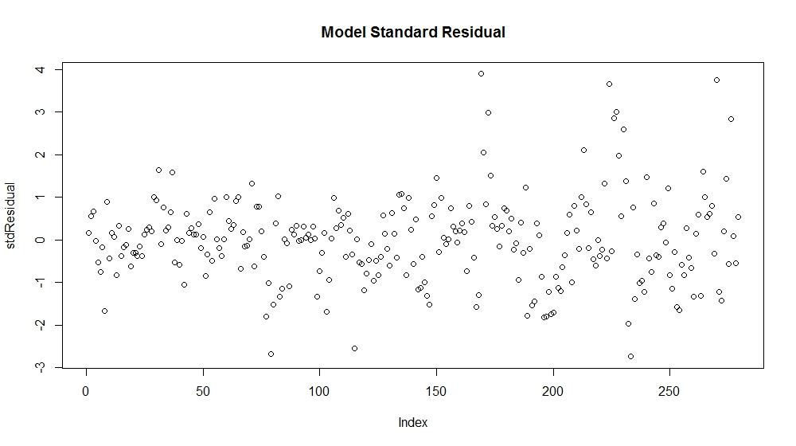

> ##Q-Q Plot

> qqPlot(model_F$residuals, main="Residual QQ Plot")

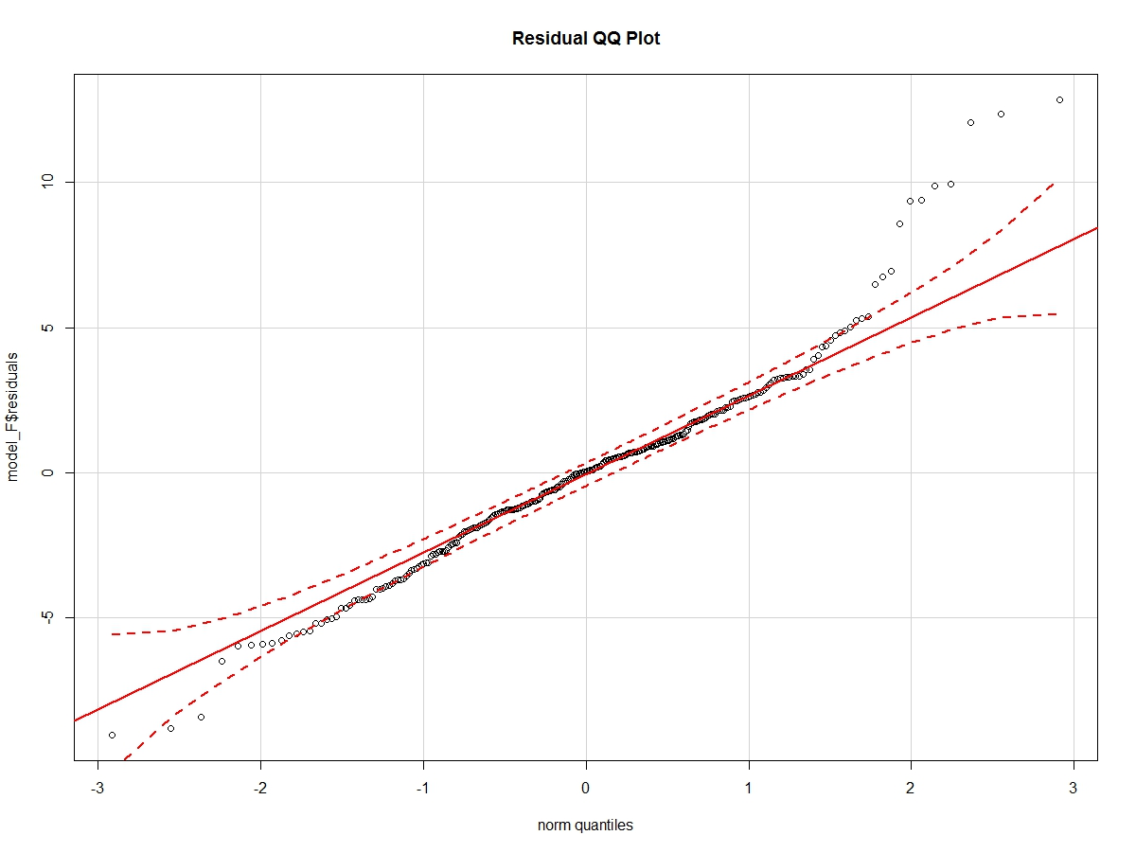

> ##Density on Histogram

> x <-model_F$residuals

> h<-hist(x, breaks=10, col="red", xlab="Residuals",

+ main="Residual Curve")

> xfit<-seq(min(x),max(x),length=40)

> yfit<-dnorm(xfit,mean=mean(x),sd=sd(x))

> yfit <- yfit*diff(h$mids[1:2])*length(x)

> lines(xfit, yfit, col="blue", lwd=2)

